Geopath Release Notes
Intermx UI Product & API Services Production Release 05.04.2022

Now Available in Production

Bug Fixes
Due to an error, users were able to enter letters or a combination of letters and numbers in the Spots Share of Voice column on line item details. Intermx corrected this issue and users can only enter numbers, represented as a percentage, in the Spots Share of Voice column.
  - JIRA Ticket: IMXDEV-112

Unit size (height x width) values should be the same on the Spot Summary and the Map View in the Explore module. A bug prevented the inches dimension from displaying correctly for the width in Map view. This has been corrected and the same values now appear for both height and width on the Spot Summary and the Map View.
Figure Spot Summary and the Map View in Explore Module
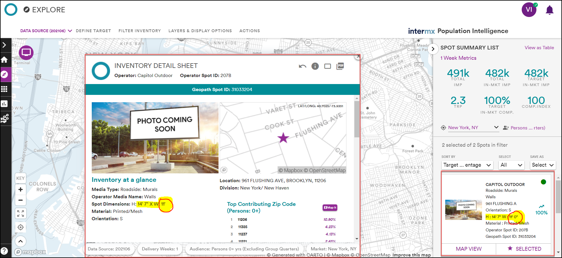
  - JIRA Ticket: IMXDEV-62

